Bloomington woman pleads not guilty to killing relative
By: Ryan Denham | September 23, 2011
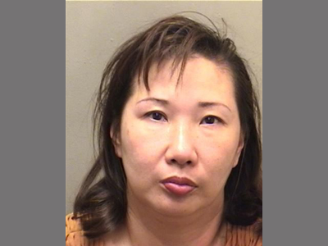
Misook Wang, 45, of Bloomington is charged with three counts of murder and one count of concealment of a homicidal death. (Courtesy photo by McLean County Sheriff's Department)
BLOOMINGTON – A 45-year-old Bloomington woman pleaded not guilty on Friday to killing her mother-in-law and trying to hide the body in a Will County forest preserve.
Misook Nowlin, also known as Misook Wang, is charged with three counts of murder and one count of concealing a homicidal death. She is accused of tricking Wenlan “Linda” Tyda, 70, of Crest Hill, Ill., into driving to Bloomington on Labor Day, and then choking her and driving the body up to the Joliet area and burying it in a shallow grave.
Nowlin made a brief appearance Friday in McLean County court in front of Judge Rebecca Foley. Nowlin, wearing a red McLean County jail jumpsuit and sandals, did not speak during the arraignment. Public Defender Kim Campbell, representing Nowlin, made the not-guilty pleas on her behalf.
A status hearing in the case is set for 9 a.m. Oct. 21.
Wang is being held in the McLean County jail on $1 million bond.
Authorities say Nowlin was fighting with Tyda over Nowlin’s marital problems. Nowlin allegedly choked Tyda to death outside Nowlin’s sewing shop in the 2400 block of East Washington Street, though she has told police that Tyda attacked first.
Ryan Denham can be reached at ryan@wjbc.com.

